**CODE**

**EchoServer.java**

import java.io.DataInputStream;

import java.io.DataOutputStream;

import java.io.IOException;

import java.net.ServerSocket;

import java.net.Socket;

public class EchoServer {

public static void main(String[] args) throws IOException {

String echoin;

ServerSocket serverSocket;

Socket socket;

try

{

serverSocket = new ServerSocket(2000);

socket = serverSocket.accept();

DataInputStream din = new DataInputStream(socket.getInputStream());

DataOutputStream dout = new DataOutputStream(socket.getOutputStream());

System.out.println("Connected for echo:");

while((echoin= din.readUTF())!=null)

{

if(echoin.equals("end"))

{

System.out.println("Client disconnected");

din.close();

break;

}

else

dout.writeUTF(echoin);

}

}

catch (Exception e){

System.out.println("Error : "+e.getMessage());

}

}

}

**OUTPUT**

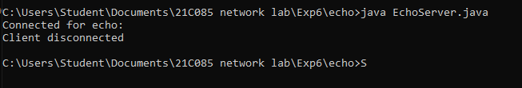

**CODE**

**EchoClient.java**

import java.io.DataInputStream;

import java.io.DataOutputStream;

import java.io.IOException;

import java.net.InetAddress;

import java.net.Socket;

import java.util.Scanner;

public class EchoClient {

public static void main(String[] args) throws IOException {

String sockin;

try

{

Socket socket = new Socket(InetAddress.getLocalHost(),2000);

Scanner sc = new Scanner(System.in);

DataInputStream din = new DataInputStream(socket.getInputStream());

DataOutputStream dout = new DataOutputStream(socket.getOutputStream());

System.out.println("Start echoing... type 'end' to terminate");

while((sockin= sc.nextLine())!=null)

{

dout.writeUTF(sockin);

if(sockin.equals("end"))

break;

else

System.out.println("echoed from server:"+din.readUTF());

}

}

catch (Exception e){

System.out.println("Error : "+e.getMessage());

}

}

}

**OUTPUT**

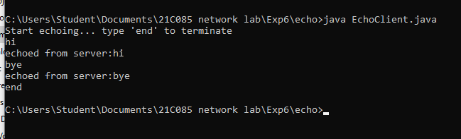

**CODE**

**PingClient.java**

import java.io.*;

import java.net.*;

import java.util.*;

public class PingClient {

public static void main(String[] args) throws IOException {

long t1, t2;

while(true){

try{

Socket socket = new Socket("localhost", 2000);

Scanner sc = new Scanner(System.in);

System.out.println("Type a string to ping : ");

String str = sc.next();

DataOutputStream dout = new DataOutputStream(socket.getOutputStream());

DataInputStream din = new DataInputStream(socket.getInputStream());

t1 = System.currentTimeMillis();

dout.writeUTF(str);

String str1 = din.readUTF();

t2 = System.currentTimeMillis();

System.out.println("Pinging "+socket.getInetAddress()+" with string "+ str);

System.out.println("Reply from "+ socket.getInetAddress()+" String "+str1+" Length : "+str1.length());

System.out.println("Sent : "+str.length()+" Recieved : "+str1.length()+" Lost : "+(str.length() - str1.length()));

System.out.println("Approx. Time in Milliseconds = "+(t2-t1));

}

catch(Exception e){

System.out.println("Error : "+e.getMessage());

}

}

}

}

**OUTPUT**

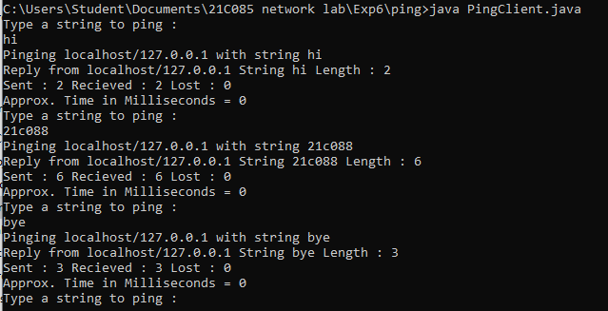

**CODE**

**PingServer.java**

import java.io.*;

import java.net.*t;

import java.util.*;

public class PingServer {

public static void main(String[] args) throws IOException {

ServerSocket serverSocket = new ServerSocket(2000);

while(true){

Socket socket = serverSocket.accept();

DataInputStream din = new DataInputStream(socket.getInputStream());

DataOutputStream dout = new DataOutputStream(socket.getOutputStream());

String str = din.readUTF();

System.out.println("Ping command received from : "+socket.getInetAddress() +" with string "+str);

dout.writeUTF(str);

}

}

}

**OUTPUT**

